**COMP90007 Internet Technologies**

**Network Analysis Assignment**

**Measuring bandwidth, delay and jitter**

Student name: Wendong Chen

Student ID: 931018

Username: wendongc1

Date: May.10th.2018

2.1

For this command line parameters **-nw1**, it’s better to divide the parameters into 2 parts to analyze.

‘**-n**’ means use IP address directly instead of mapping the IP address to host name.

‘**-w**’ is wait-time. You can set the waiting time (in seconds) for a response to a probe and the default is 5.0 sec. In this assignment, the wait-time is 1s, i.e., -w 1.

2.2

|  |  |  |  |
| --- | --- | --- | --- |
| **Server** | **Country** | **Distance(km)** | **Hop count** |
| iperf.he.net | USA | 12691.12 | 16 |
| bouygues.testdebit.info | France | 16616.46 | 24 |
| iperf.comneonext.de | Germany | 16643.33 | 28 |
| ikoula.testdebit.info | France | 16817.66 | 29 |
| st2.nn.ertelecom.ru | Russia | 14072.9 | 23 |
| iperf.eenet.ee | Estonia | 15126.31 | 29 |
| iperf.scottlinux.net | USA | 12787.8 | 18 |
| iperf.volia.net | Ukraine | 14795.67 | 32 |

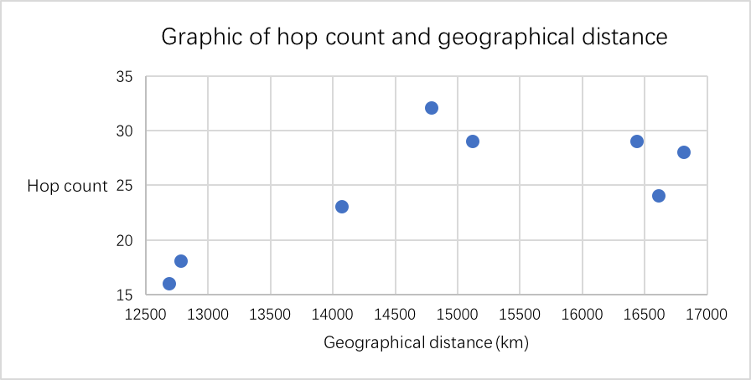

In general, when the distance becomes longer, the longer communication path may result in an increment in the number of routers through which the packets pass, i.e., increment in the number of hops. Of course, distance is just one of the reasons, as well as the network quality and routing algorithms.

From the figure, I can observe that the distance presents increasing with the hop count, but the dependency relation is not very significant. There is an exception that the server of which distance is 16616 km only has 24 hops. The number of samples is too small, so it’s difficult to get a clear correlation.

3.1

Delay is an important factor of the network quality and jitter is generated based on delay, i.e., the standard deviation of the RTT for this project. High delay and high jitter means the condition of network is bad, unstable or congested and this will lead to poor user experience.

There are lots of applications that are sensitive to both high delay and high jitter, like video call, VoIP (Voice over Internet Protocol). Users will sense the delay when the delay is greater than 150ms during a voice call. For video call, it will affect user experience when the delay is greater than 400ms. Furthermore, jitter also has bad effects. It will cause video quiver or even a small count of jitter will influence the QoS, e.g., jerky video frames and unintelligible audio.

3.2

|  |  |  |  |  |
| --- | --- | --- | --- | --- |
| **Server** | **Country** | **Distance(km)** | **Average round-trip delay(ms)** | **Average**  **jitter(ms)** |
| iperf.he.net | USA | 12691.12 | 163.915 | 0.289 |
| bouygues.testdebit.info | France | 16616.46 | 306.201 | 0.394 |
| iperf.comneonext.de | Germany | 16643.33 | 308.913 | 0.606 |
| ikoula.testdebit.info | France | 16817.66 | 305.319 | 0.455 |
| st2.nn.ertelecom.ru | Russia | 14072.9 | 358.137 | 0.428 |
| iperf.eenet.ee | Estonia | 15126.31 | 354.978 | 0.654 |
| iperf.scottlinux.net | USA | 12787.8 | 164.322 | 0.379 |
| iperf.volia.net | Ukraine | 14795.67 | 351.721 | 0.345 |

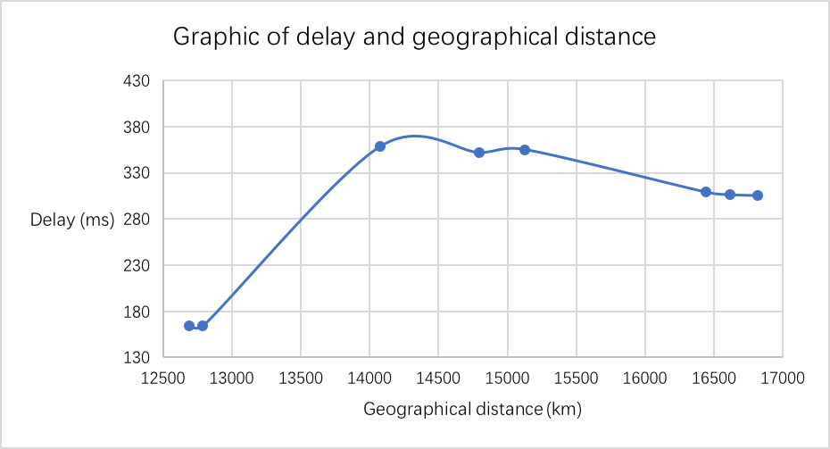

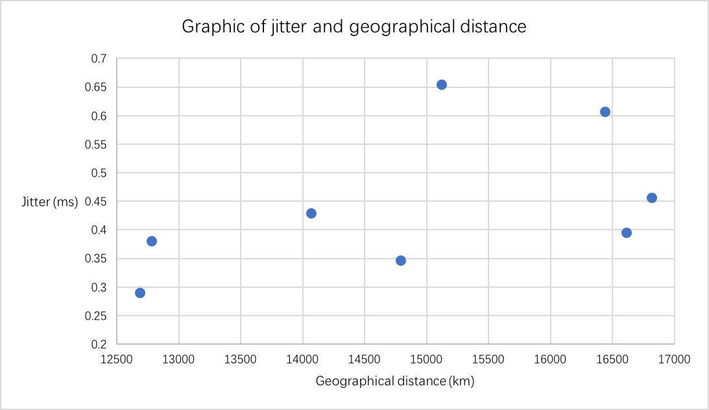

To find the location of IP address: <https://db-ip.com>

To find the geographical distance: <http://www.gpsspg.com/distance.htm>

3.3

As we can see, as the distance becomes longer, the round-trip delay becomes relatively longer. The delays of servers in the former Soviet countries (Estonia, Ukraine, Russia) located between 14,000 to 15,200 kilometers from me are slightly longer than those for European countries (France, Germany) with distance of approximately 16,000 kilometers. This may be due to the better quality of European network links (perhaps because the economy or the Internet industry is more developed). The ping of my network is 1ms, it’s much shorter than the delay I have measured, so the delay is not caused by my network environment. My conclusion is that the geographical distance can affect the delay to some extent but it is only one of the factors.

As for jitter, I did not observe any obvious relationship from the figure. In fact, jitter is related to the stability of the network. The stronger the stability of the network, the smaller the change in delay, i.e., the smaller the jitter. The congested network, the bad link quality, the different routes of packets’ transmission, all the factors will cause jitter. The jitter of my network is about 0.3ms, so it’s close to the measured data.

4.1

The bandwidth delay product is the maximum amount of data on the link. If the number of bits are sent in the link, it indicates that the link is fully utilized. Satellite transmission is an example of a high-bandwidth delay product. Because the link length is very long and the round-trip delay is very large, the data in the link will be many, and it will have a high-bandwidth delay product.

Throughput efficiency is the successful delivery rate of data, so larger throughput means faster data transmission and the maximum amount of data on the network is larger accordingly, i.e., larger bandwidth-delay product. If the throughput is small and the bandwidth-delay product is large, it will lead to congestion and tries to manage it by dropping packets.

The relation between throughput and bandwidth-delay product:

$$Throughput=\frac{Total data}{\frac{Total data}{Bandwidth}+Delay}=\frac{Total data*Bandwidth}{Total data+Bandwidth*Delay}$$

4.2

|  |  |  |  |
| --- | --- | --- | --- |
| **Server** | **Country** | **Distance(km)** | **Bandwidth(Mbps)** |
| iperf.he.net | USA | 12691.12 | 78.43 |
| bouygues.testdebit.info | France | 16616.46 | 62.37 |
| iperf.comneonext.de | Germany | 16643.33 | 26.1 |
| ikoula.testdebit.info | France | 16817.66 | 29.13 |
| st2.nn.ertelecom.ru | Russia | 14072.9 | 11.47 |
| iperf.eenet.ee | Estonia | 15126.31 | 45.2 |
| iperf.scottlinux.net | USA | 12787.8 | 116 |
| iperf.volia.net | Ukraine | 14795.67 | 46.87 |

4.3

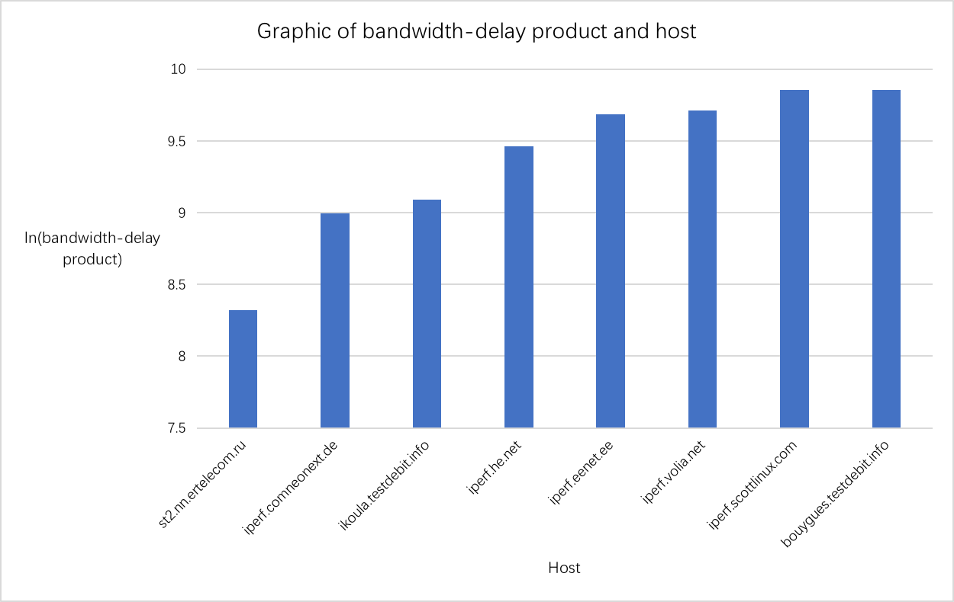

The data is measured by the campus wireless network. The campus network has high bandwidth, up to 129Mb. However, the bandwidth measured with ‘iperf’ is between 10Mb and 120Mb, which is below the maximum bandwidth of the campus network and varies greatly. This may be because some ISPs limit my outbound bandwidth due to congestion control, or the wireless network is not very stable. There is an outlier in my data. The Russian server ‘st2.nn.ertelecom.ru’ is unusual because its bandwidth-delay product is much smaller than other servers.

4.4

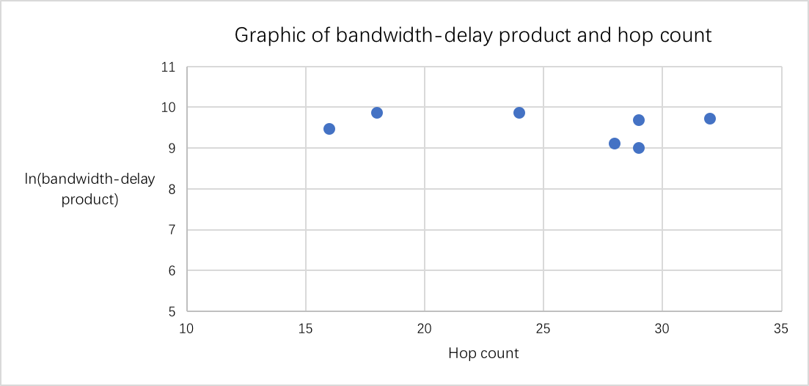

I don't think there is any correlation between hop count and bandwidth-delay product. The first point is that the sample size is too small; the second is because the bandwidth-delay product represents the maximum amount of data on the link and the hop count means the number of routers packets pass through. There is no obvious relationship between them.

4.5

|  |  |  |  |
| --- | --- | --- | --- |
| **Command** | **Parameter** | **Function** | **Tool** |
| traceroute | -nw 1(-nw 1), -m | hop count | Terminal |
| ping |  | delay, jitter |
| iperf | -c, -p | bandwidth |

|  |  |  |
| --- | --- | --- |
| **Attribute** | **Value** | **Tool** |
| Download | 129Mbps | www.speedtest.net |
| Update | 71.7Mbps |
| Ping | 1ms |
| Jitter | 0.33ms |

Plotting software: Excel

Operating system: macOS 10.12.6

Type of network: Wireless Local Area Network of the University of Melbourne

I think the network type may affect the accuracy or reliability of results to some extent, because wireless network is not very stable. Also, there are lots of people using the campus network so it’s more likely to cause network congestion. To solve this problem, changing a stable wired network and making measurements at night (early morning) is a good solution. Last but not least, the sample capacity is way too small, only 8 sets of results, so it’s difficult to get accurate and reliable results. The sample capacity should be increased.

In general, collecting accurate information in networks is very difficult. There are too many uncontrollable factors which can affect the results, such as network congestion, quality of communication link, router performance, etc. What we can do to get more accurate information in networks is choose a suitable time when few people use the internet and make more measurements.

**Appendix**

1. Results of ‘traceroute’ (hop count)

iperf.he.net:

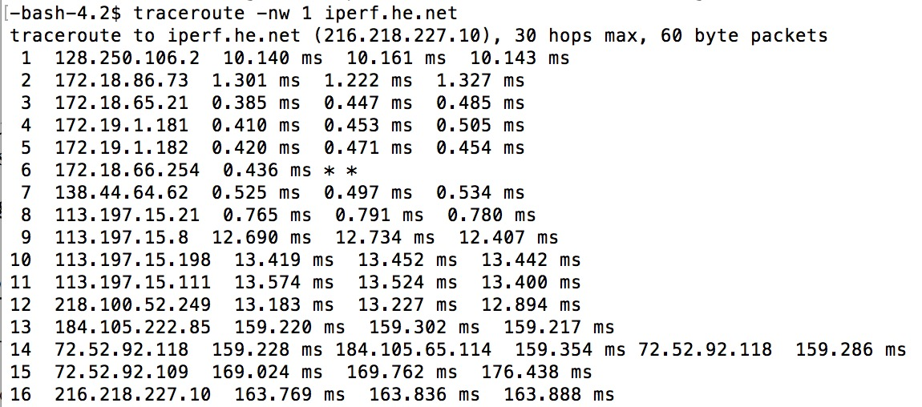

bouygues.testdebit.info:

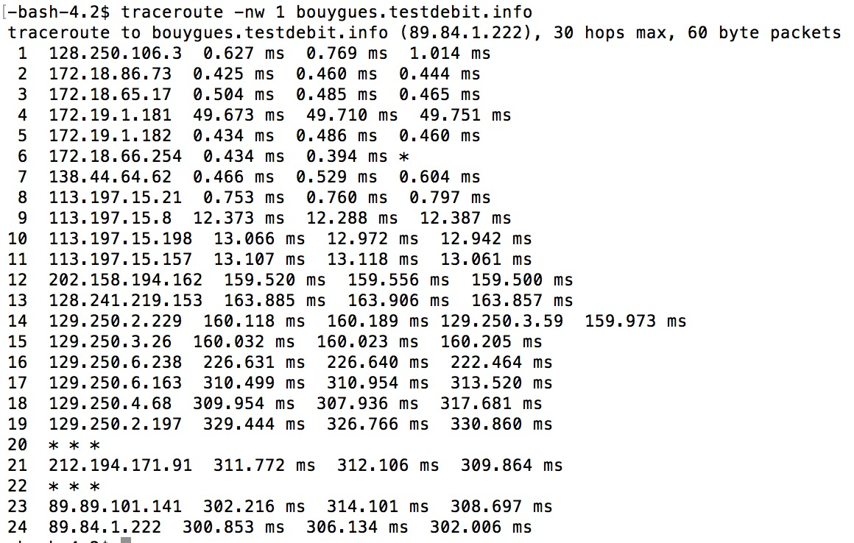

iperf.comneonext.de:

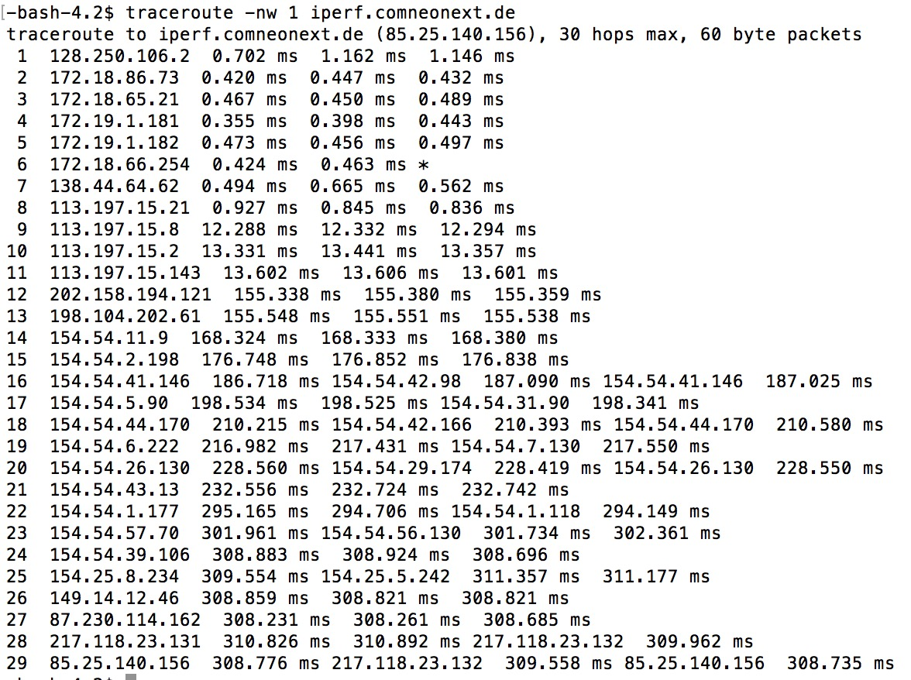

ikoula.testdebit.info:

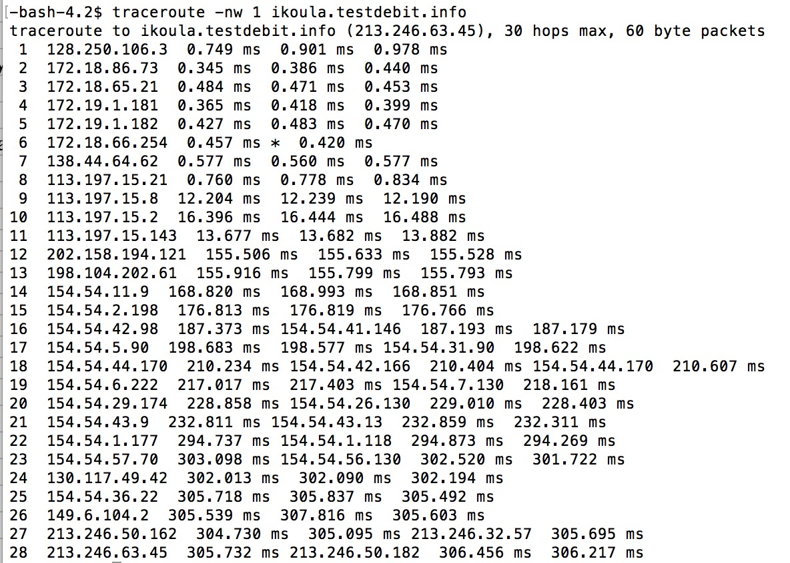

st2.nn.ertelecom.ru:

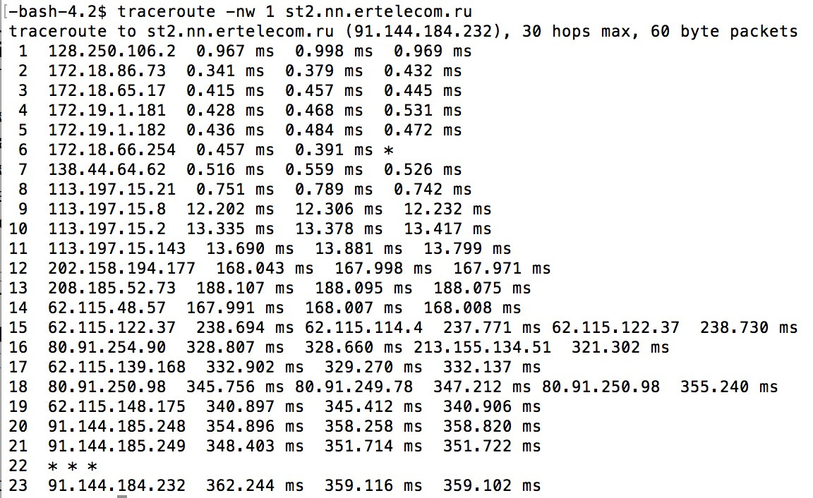

iperf.eenet.ee:

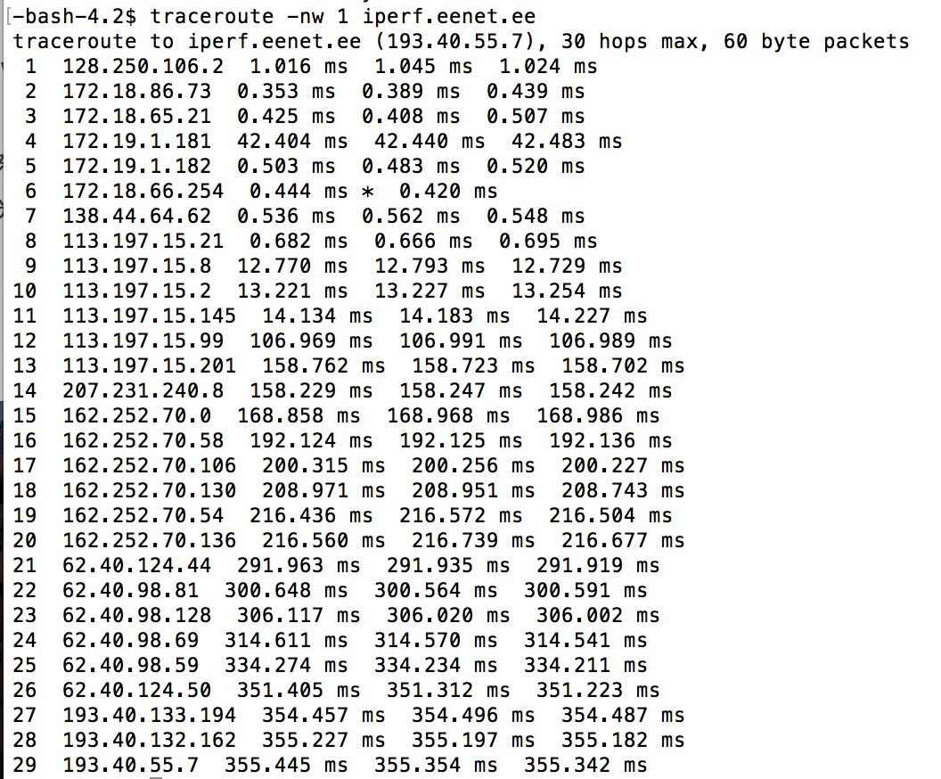

iperf.scottlinux.com:

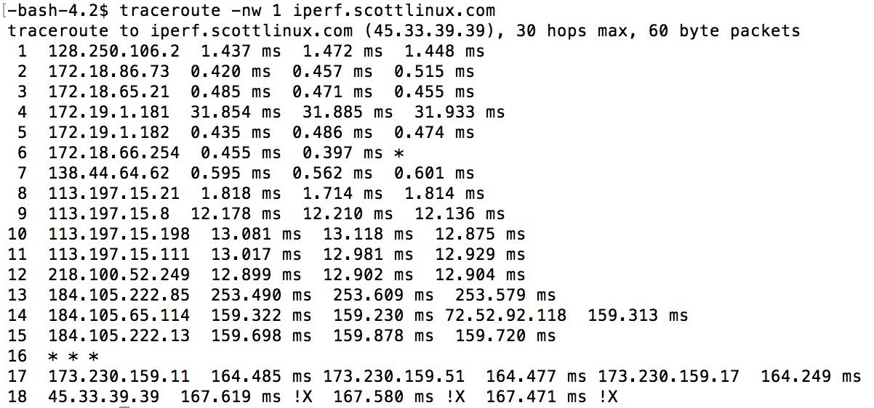

iperf.volia.net:

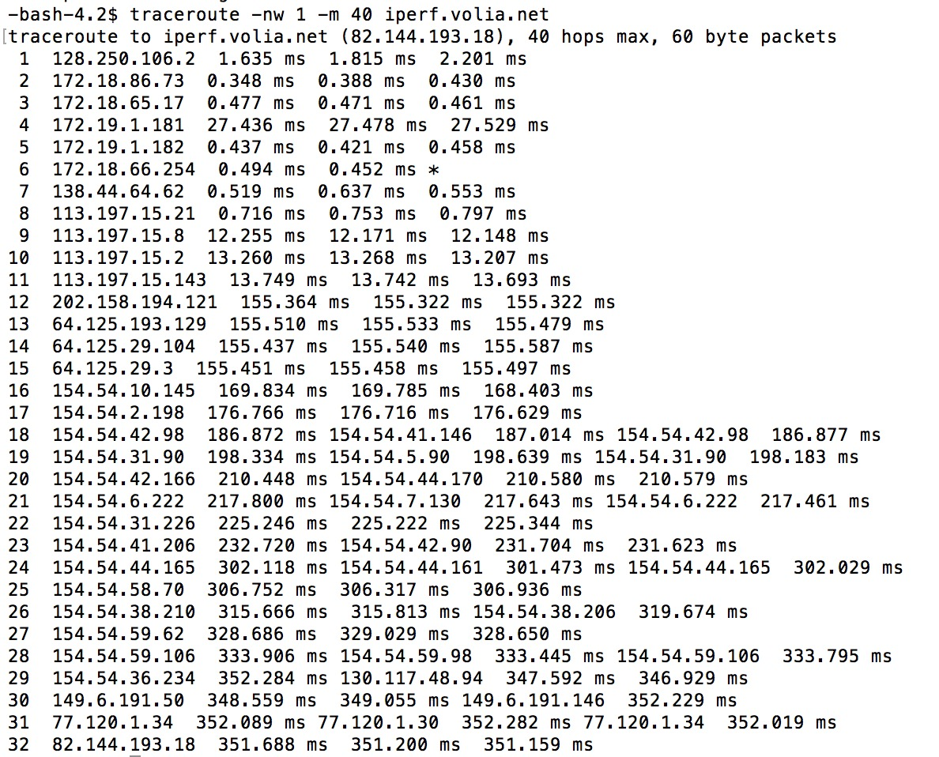

1. Results of ‘ping’ (round trip delay and jitter)

iperf.he.net:

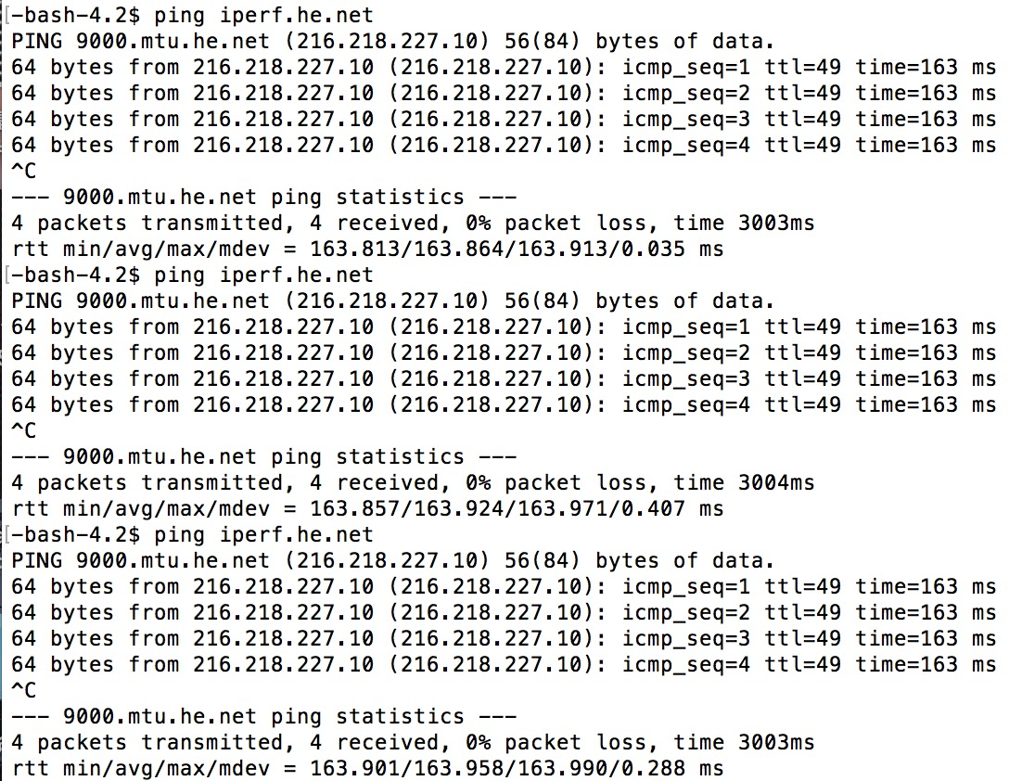

bouygues.testdebit.info:

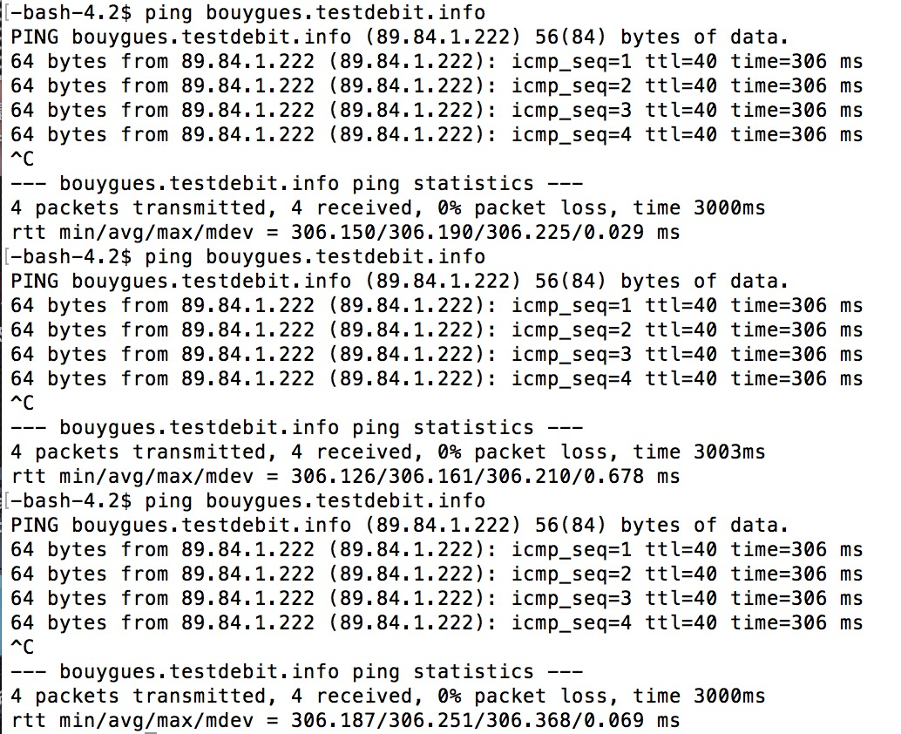

iperf.comneonext.de:

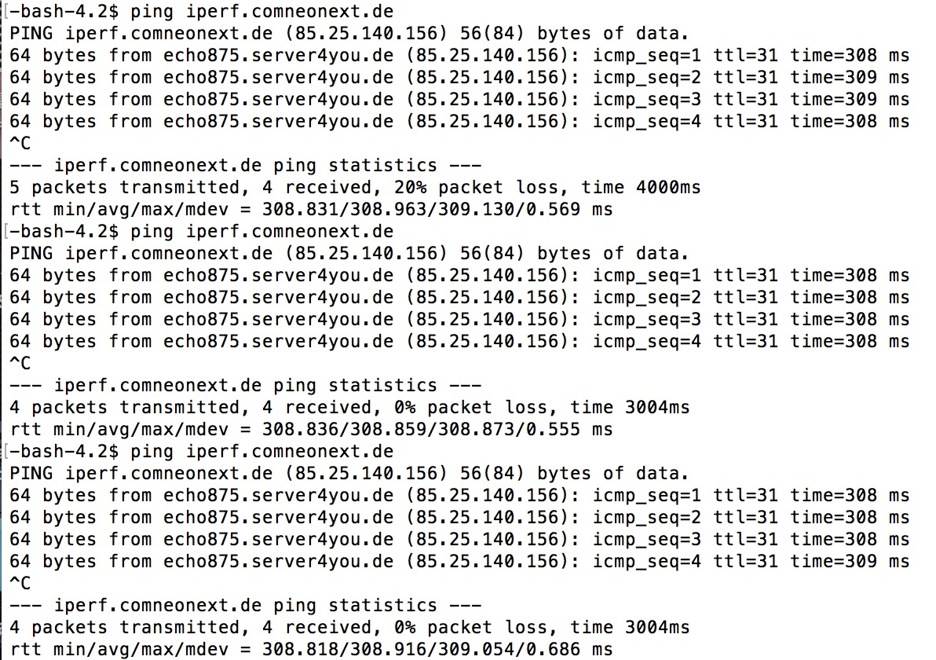

ikoula.testdebit.info:

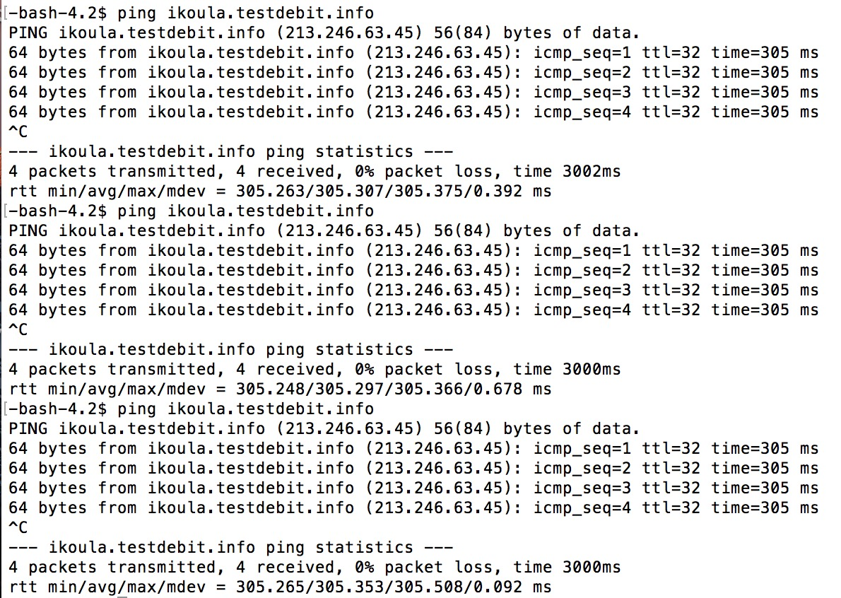

st2.nn.ertelecom.ru:

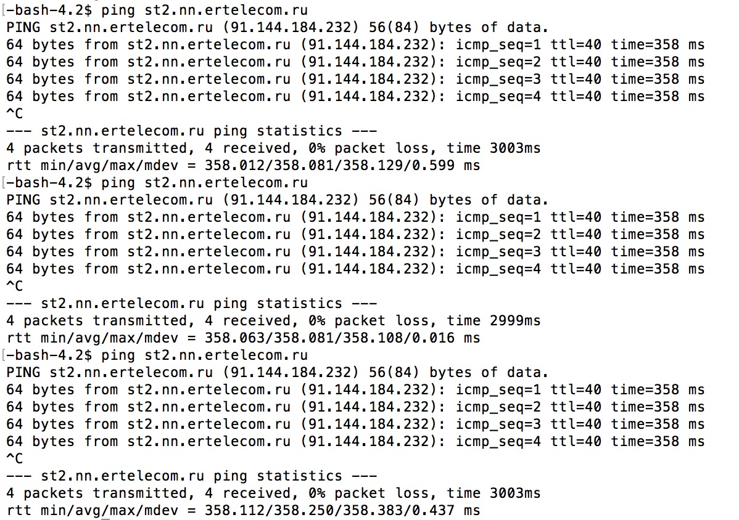

iperf.eenet.ee:

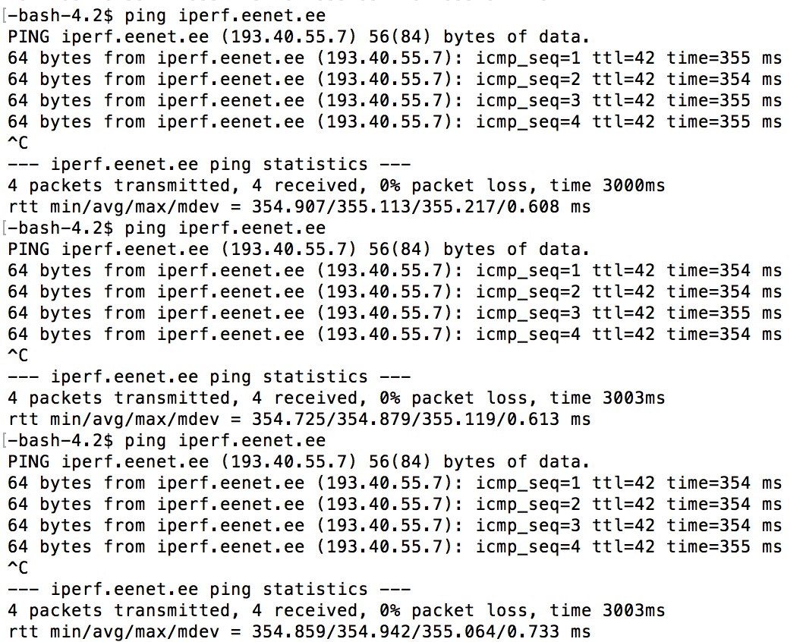

iperf.scottlinux.com:

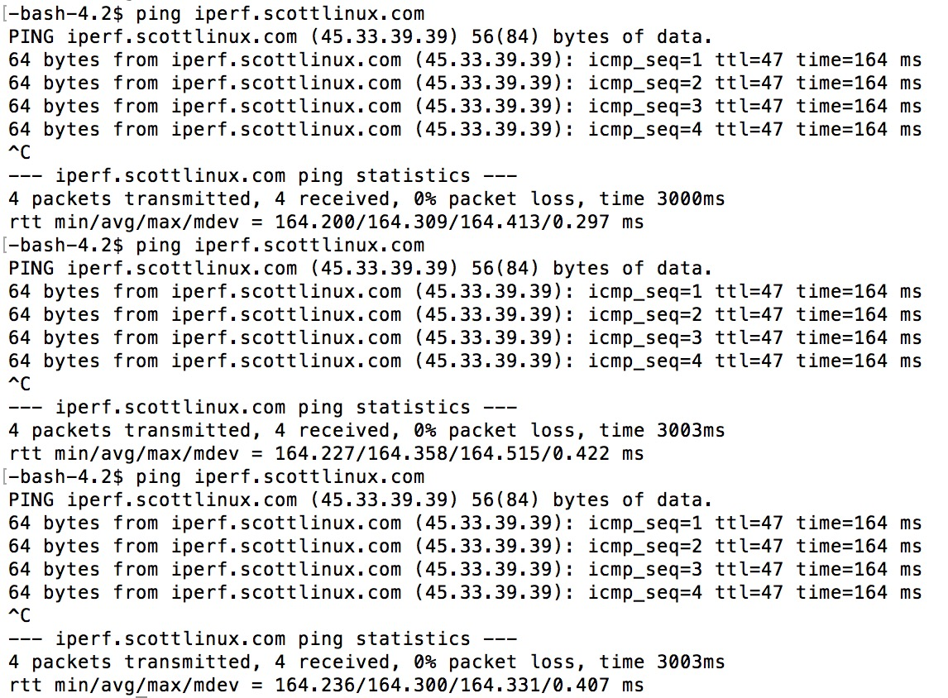

iperf.volia.net:

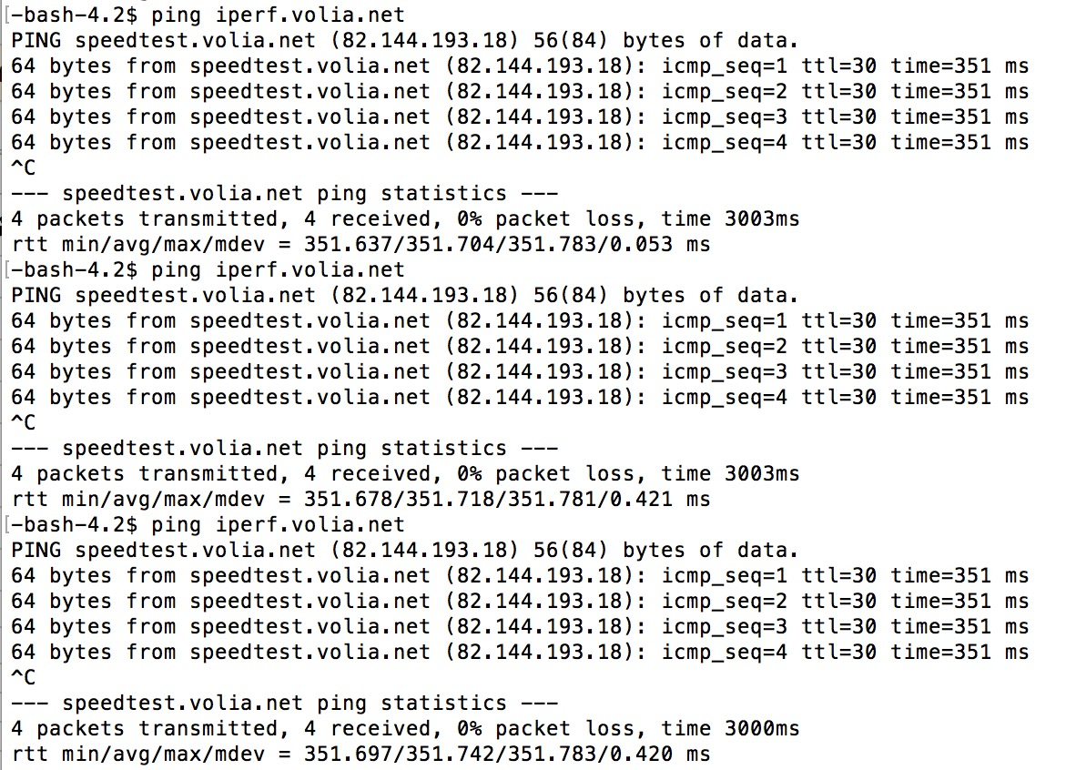

1. Results of ‘iperf’ (bandwidth)

iperf.he.net:

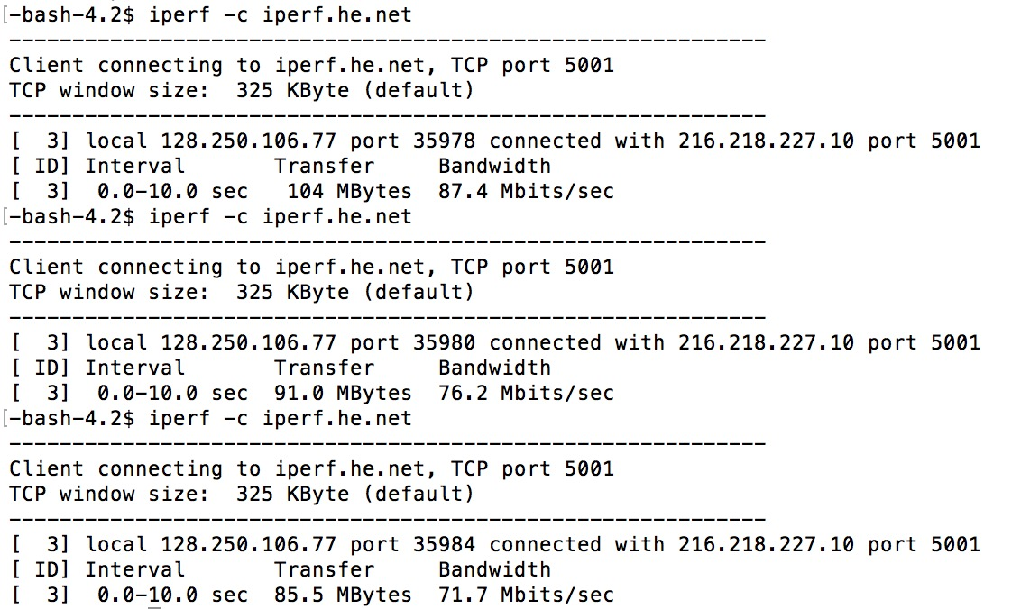

bouygues.testdebit.info

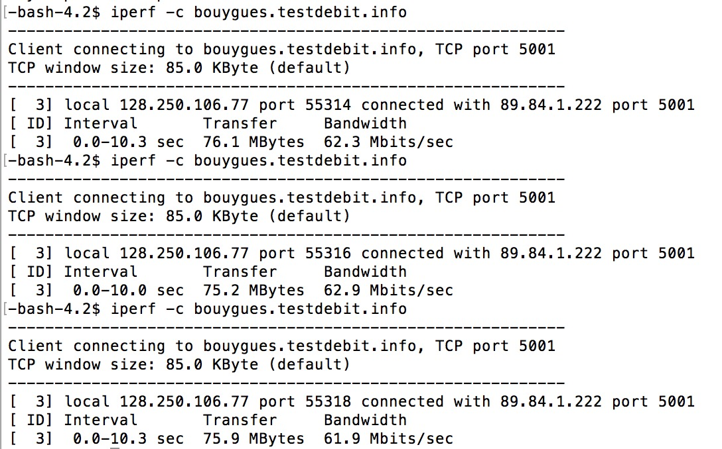

iperf.comneonext.de:

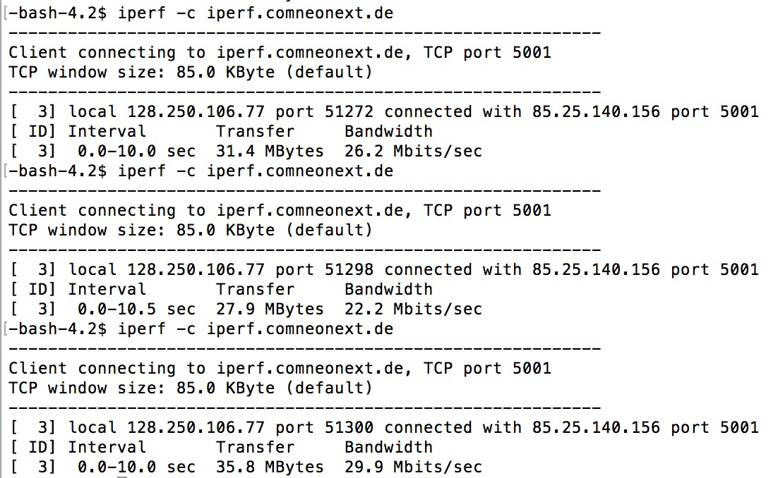

ikoula.testdebit.info:

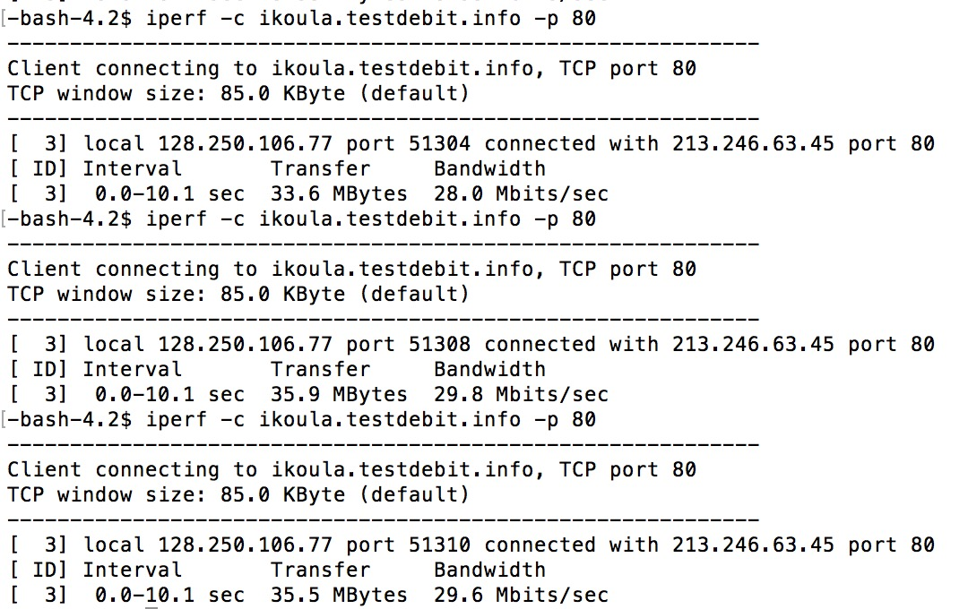

st2.nn.ertelecom.ru:

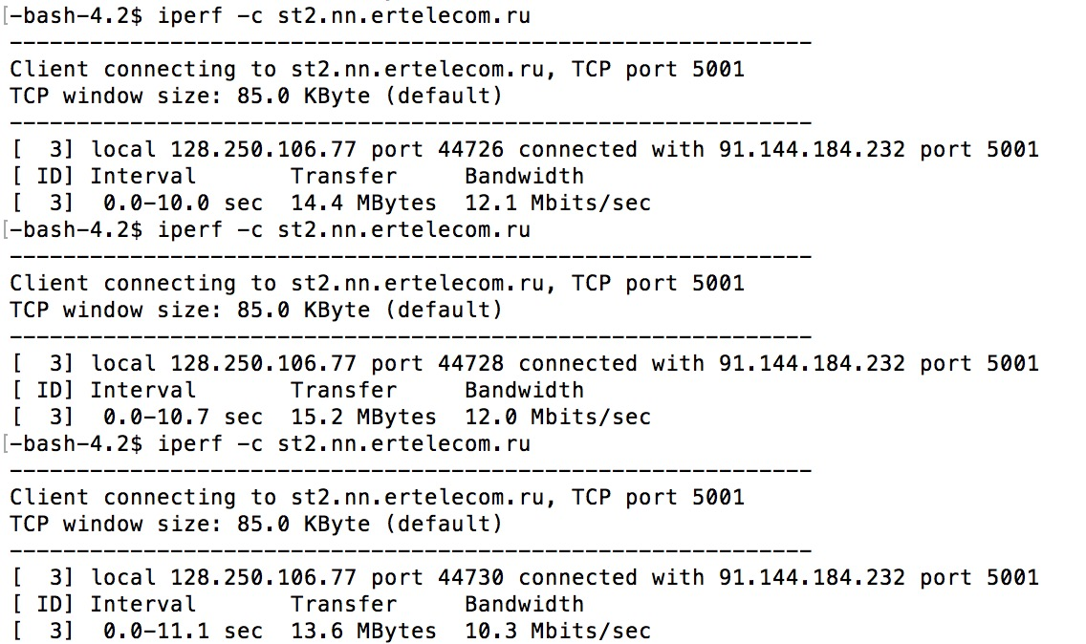

iperf.eenet.ee:

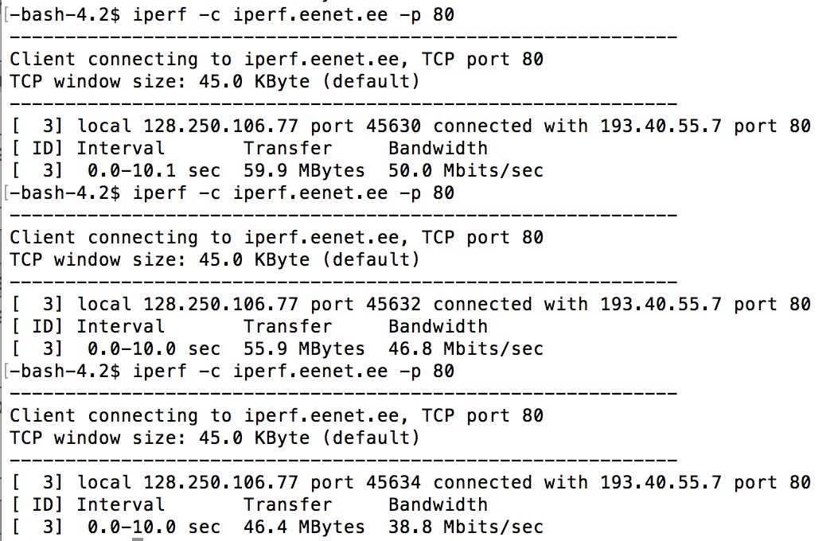

iperf.scottlinux.com:

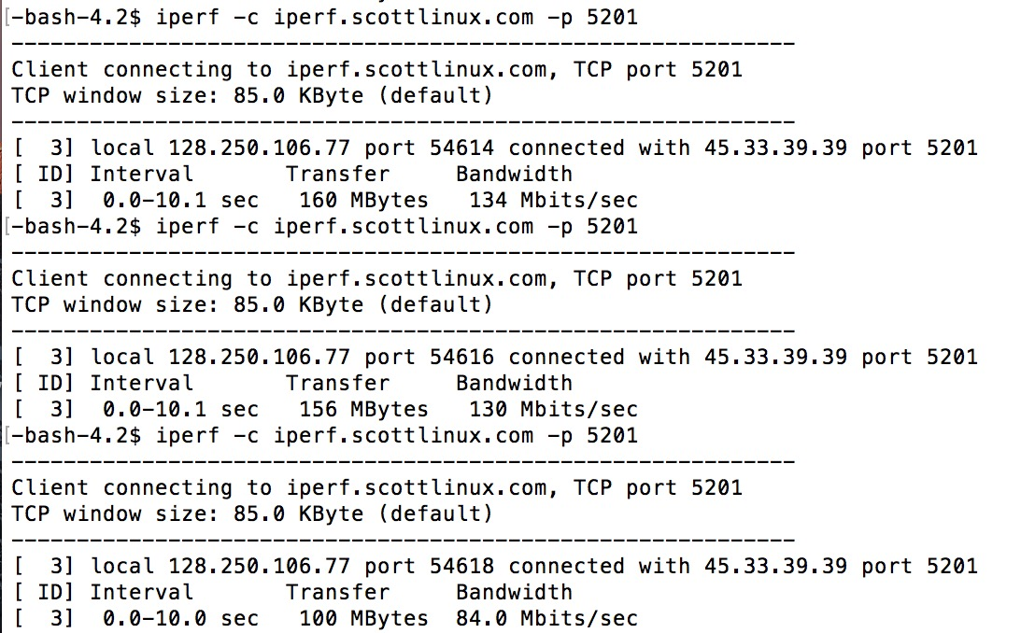

iperf.volia.net:

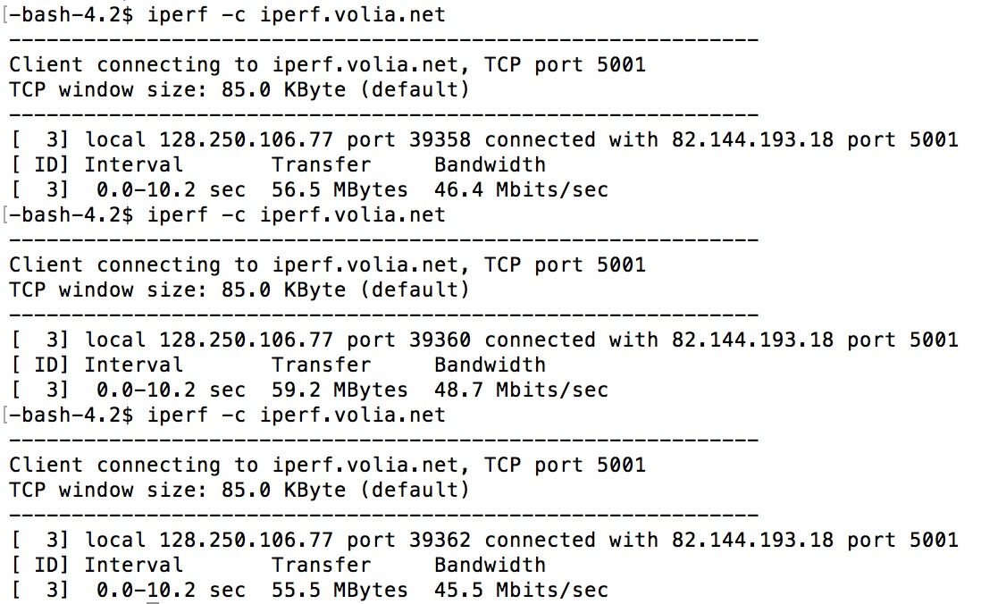

1. Network environment:

